PRUSSIA
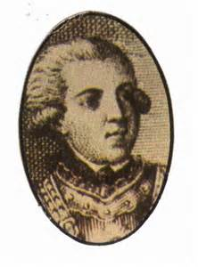
COMMANDER IN CHIEF
EXCELLENT

PRUSSIA
COMMANDER IN CHIEF
EXCELLENT

PRUSSIA
COMMANDER IN CHIEF
EXCELLENT

PRUSSIA
COMMANDER IN CHIEF
EXCELLENT

PRUSSIA
COMMANDER IN CHIEF
EXCELLENT

PRUSSIA
COMMANDER IN CHIEF
EXCELLENT

PRUSSIA
COMMANDER IN CHIEF
EXCELLENT

PRUSSIA
COMMANDER IN CHIEF
EXCELLENT

RE-SHUFFLE
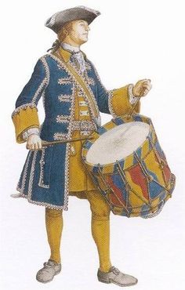
In Active commands may rally and move Commanders

RE-SHUFFLE
In Active commands may rally and move Commanders

RE-SHUFFLE
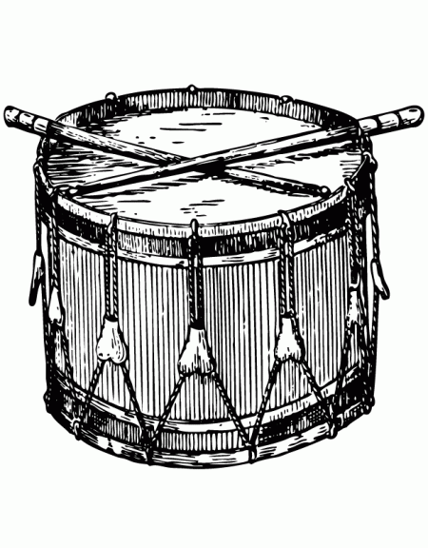
In Active commands may rally and move Commanders

RE-SHUFFLE
In Active commands may rally and move Commanders

